# ASSIGNMENT (UNIT - 2)

**Aim: Create Mail merge, HLOOKUP, Five Charts.**

**Mail Merge**

Dear Faker (Sang-hyeok Lee),

Join us for an electrifying Valorant Esports Event!

Date: November 12, 2023

Time: 4:00 PM

Location: 120 W 5th St, Santa Ana, CA 92701

Experience:

- High-stakes Valorant matches

- Shoutcasting by esports commentators

- Giveaways and prizes

- Networking with fellow gamers

All levels of gamers are welcome, so bring friends and family. Please RSVP by November 5, 2023, to secure your spot.

Best regards,

Rishi Joshi

Dear s1mple (Oleksandr Kostyliev),

Join us for an electrifying Valorant Esports Event!

Date: November 12, 2023

Time: 4:00 PM

Location: 120 W 5th St, Santa Ana, CA 92701

Experience:

- High-stakes Valorant matches

- Shoutcasting by esports commentators

- Giveaways and prizes

- Networking with fellow gamers

All levels of gamers are welcome, so bring friends and family. Please RSVP by November 5, 2023, to secure your spot.

Best regards,

Rishi Joshi

Dear Ninja (Tyler Blevins),

Join us for an electrifying Valorant Esports Event!

Date: November 12, 2023

Time: 4:00 PM

Location: 120 W 5th St, Santa Ana, CA 92701

Experience:

- High-stakes Valorant matches

- Shoutcasting by esports commentators

- Giveaways and prizes

- Networking with fellow gamers

All levels of gamers are welcome, so bring friends and family. Please RSVP by November 5, 2023, to secure your spot.

Best regards,

Rishi Joshi

Dear Shroud (Michael Grzesiek),

Join us for an electrifying Valorant Esports Event!

Date: November 12, 2023

Time: 4:00 PM

Location: 120 W 5th St, Santa Ana, CA 92701

Experience:

- High-stakes Valorant matches

- Shoutcasting by esports commentators

- Giveaways and prizes

- Networking with fellow gamers

All levels of gamers are welcome, so bring friends and family. Please RSVP by November 5, 2023, to secure your spot.

Best regards,

Rishi Joshi

**Five Charts**

**HLOOKUP**  
  
  
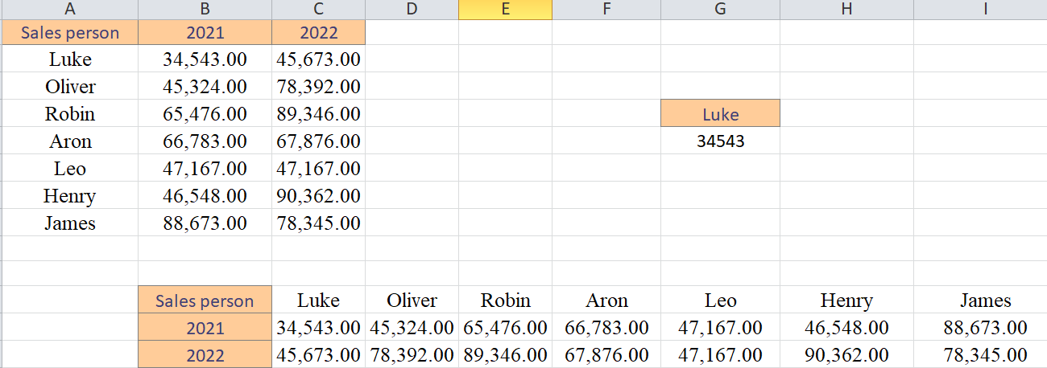  
  
=HLOOKUP(2021, A1:C7, MATCH("Oliver", A1:C8, 0), FALSE)

=HLOOKUP(2022, A1:C7, MATCH("Oliver", A1:C8, 0), FALSE)  
